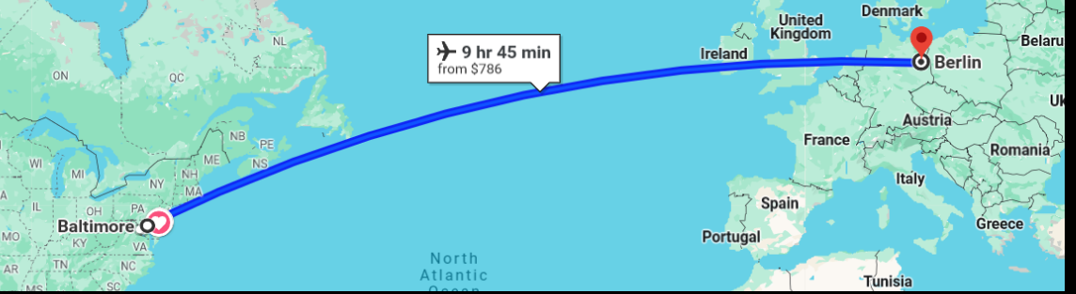
Max Kade Center 2024 Summer Travel Grant
for Study / Internships in Germany
Deadline: April 1, 2024

The German Program, with the support of the Max Kade Center for Modern German Thought, is pleased to announce 10 Travel Grants in the amount of $1,500 to support summer study abroad (German language courses, seminars in other disciplines, internships) in Germany.
Eligibility: Applicants must be full-time undergraduates at Johns Hopkins University. Prior knowledge of German is not required to apply for the grant and students from across the university are encouraged to apply. Preference is given to students who are German majors, German minors or students enrolled in courses in the German program, but all Hopkins undergraduates are eligible to apply.
Application Process: Please create one PDF of all documents and send to Deborah Mifflin (mifflind@jhu.edu). Applications are due by April 1 and must include:
___ Application Form (See page 2)
___ Copy of Transcript
___ Name of Academic Advisor (as reference)
___Statement of Purpose (reasons for studying German & studying in Germany, ½ - 1 page)
___Detailed information about the program applicant has applied to / intends to apply to or internship student will complete. If already accepted, please include acceptance document.

For more information about the grant and/or eligible programs, contact Professor Jacob Haubenreich jhauben2@jhu.edu, the German Director of Undergraduate Studies, or Deborah Mifflin mifflind@jhu.edu, the German Language Program Director.

The Max Kade Center Summer Travel Grant
April 1, 2023 Deadline
Application Form (Complete & submit along with transcript, Statement of Purpose, & Information on Program Applying to as one document named LAST NAME MAX KADE and send to mifflind@jhu.edu.)
Full Name: ___________________________________________________________________________
Address: _____________________________________________________________________________
_____________________________________________________________________________________
Email: _____________________________ Phone:____________________________________________
Year of Study: _____ Freshman ____ Sophomore ____ Junior ____ Senior
Academic Major(s):___________________________________________
Academic Minor(s):___________________________________________
Academic Advisor:____________________________________________________________________
Previous Courses in German at Hopkins:___________________________________________________
____________________________________________________________________________________
Current Course(s) in German: ____________________________________________________________
_____________________________________________________________________________________
Summer Program applying to: ____________________________________________________________
Exact place & dates (include URL): _________________________________________________________
Proposed plans for study: ________________________________________________________________
_____________________________________________________________________________________

Submit application packet via email with subject line LAST NAME MAX KADE APPLICATION to:
Deborah McGee Mifflin, German Language Program Director, Department of Modern Languages & Literatures mifflind@jhu.edu

